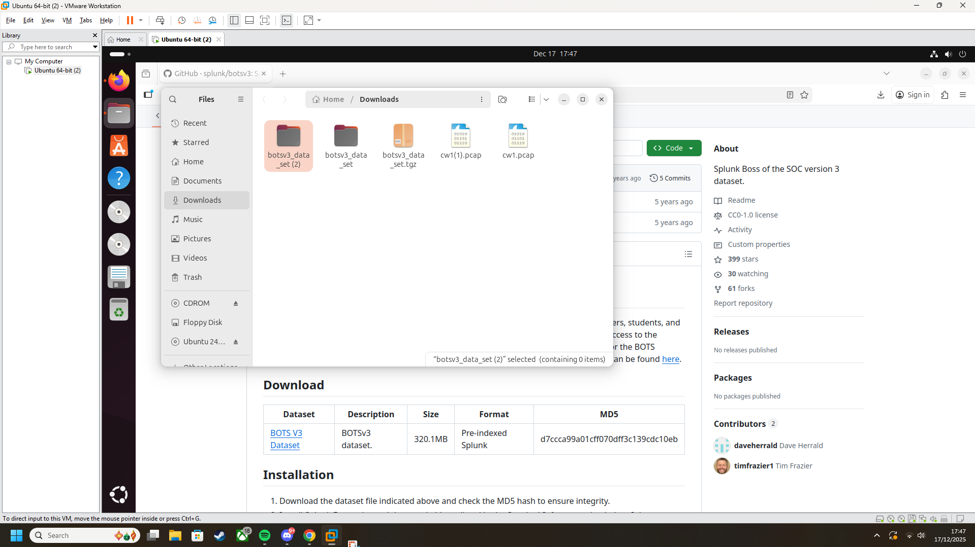

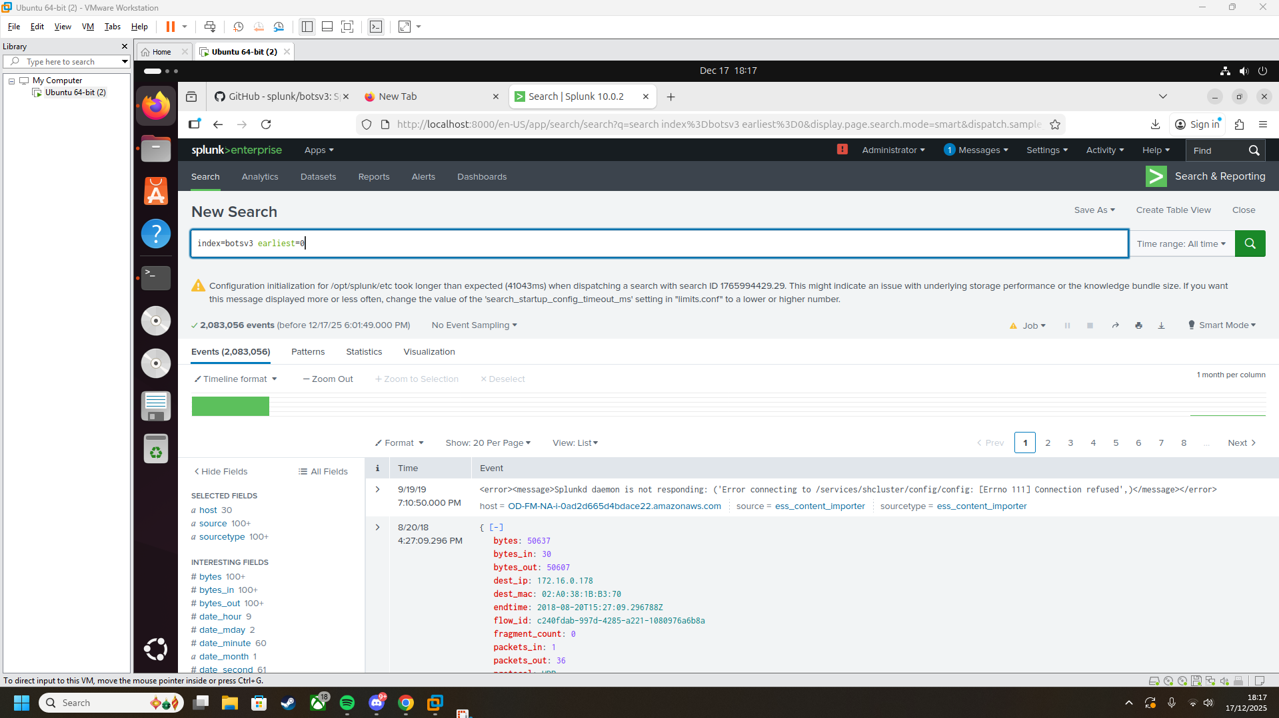

Question 1

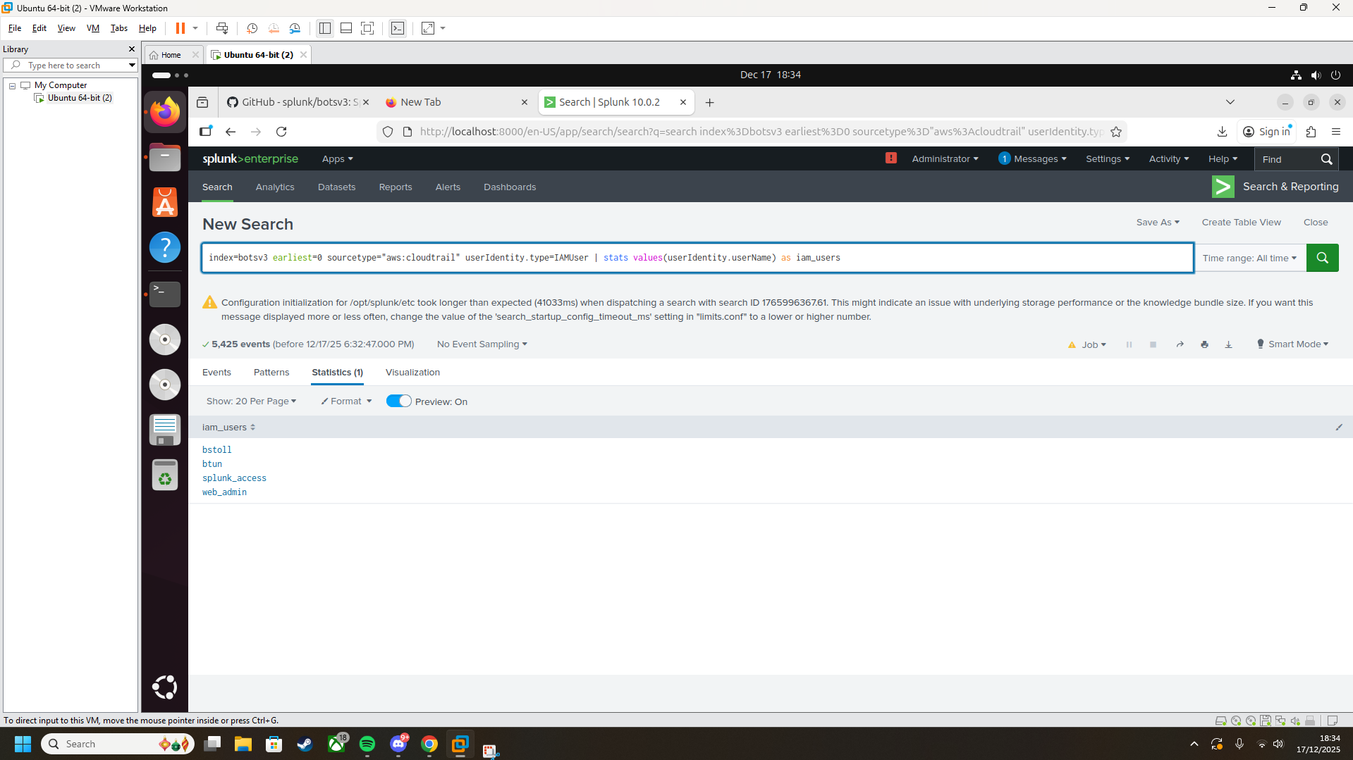

Question 2

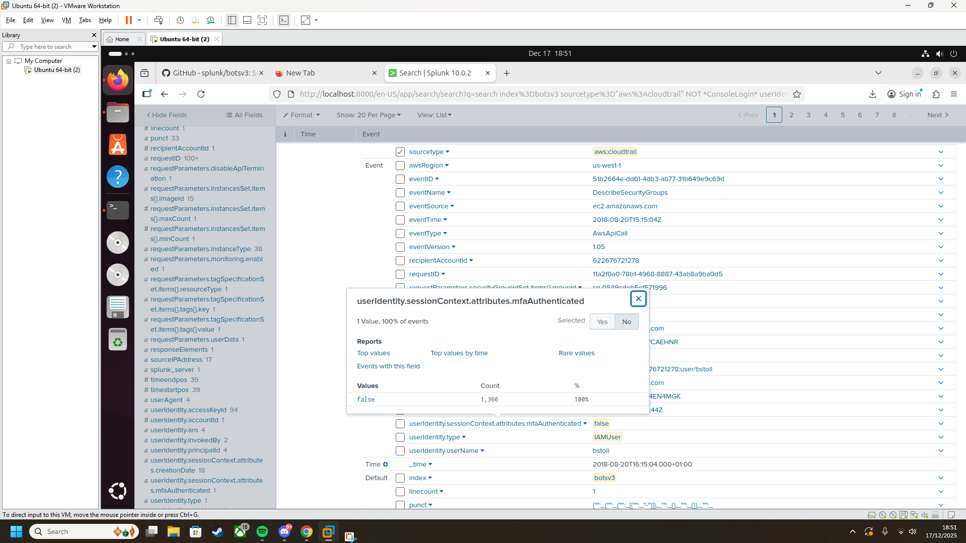

Question 3

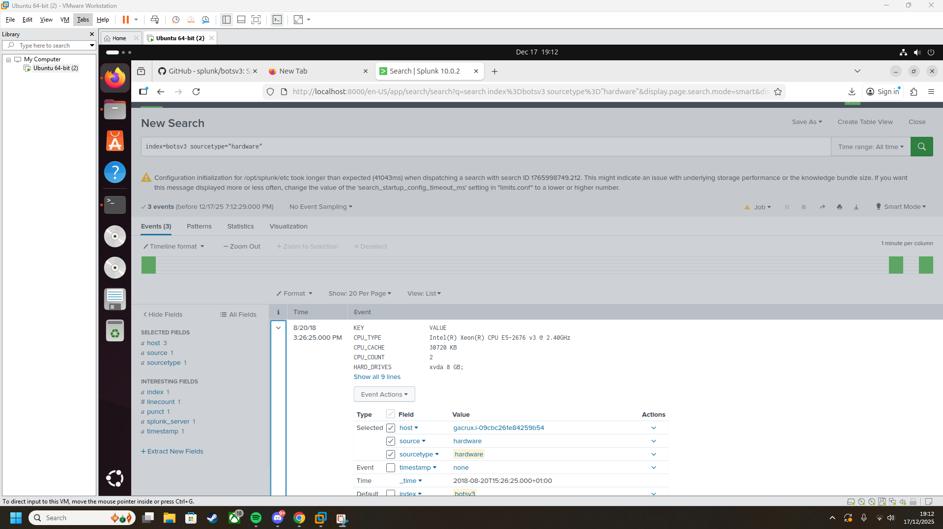Shown under CPU TYPE

Question 4 and 5

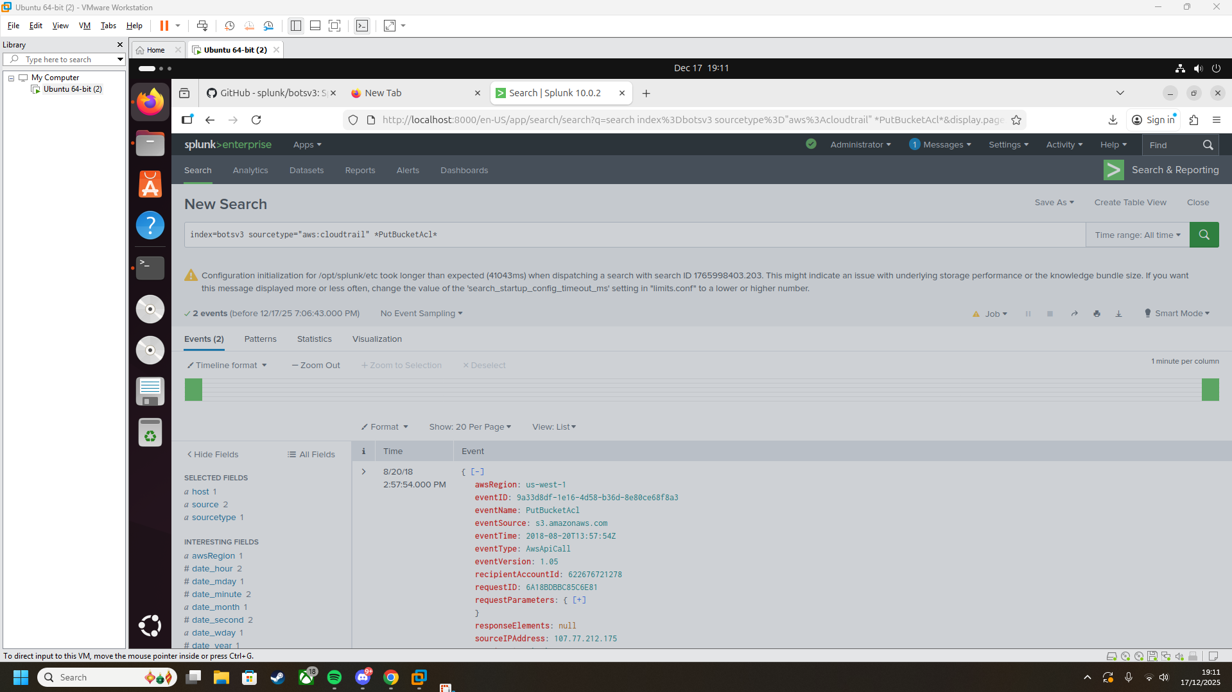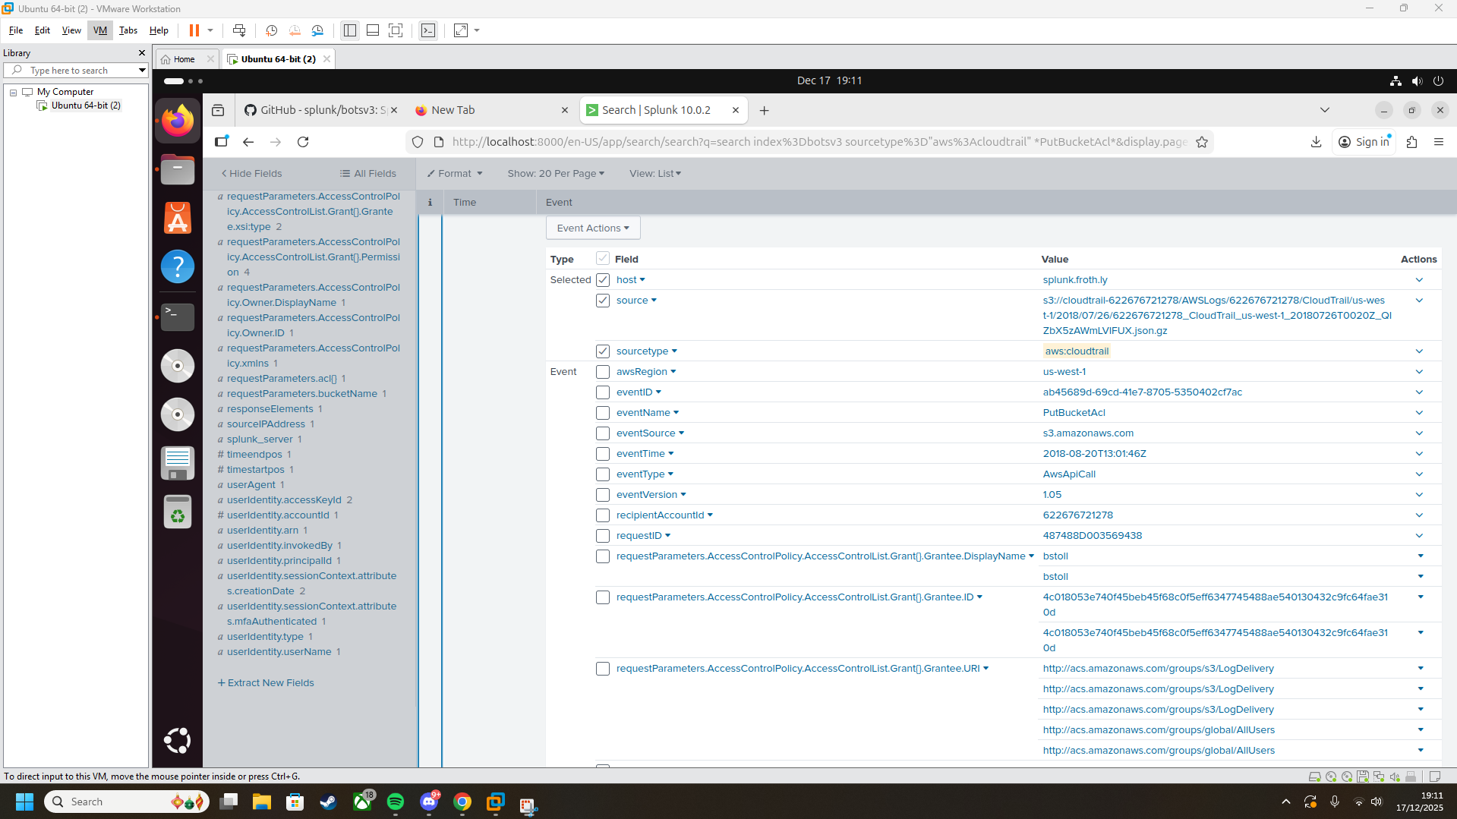shows event id and the username attached to it, which is Buds.

Question 6

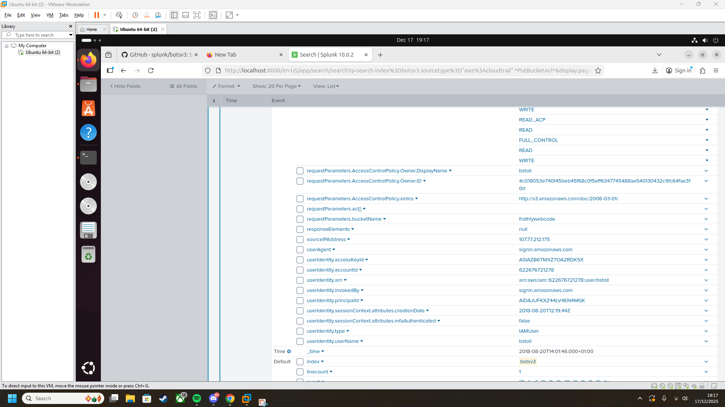Listed under requestParameters.bucketName

QUESTION 7

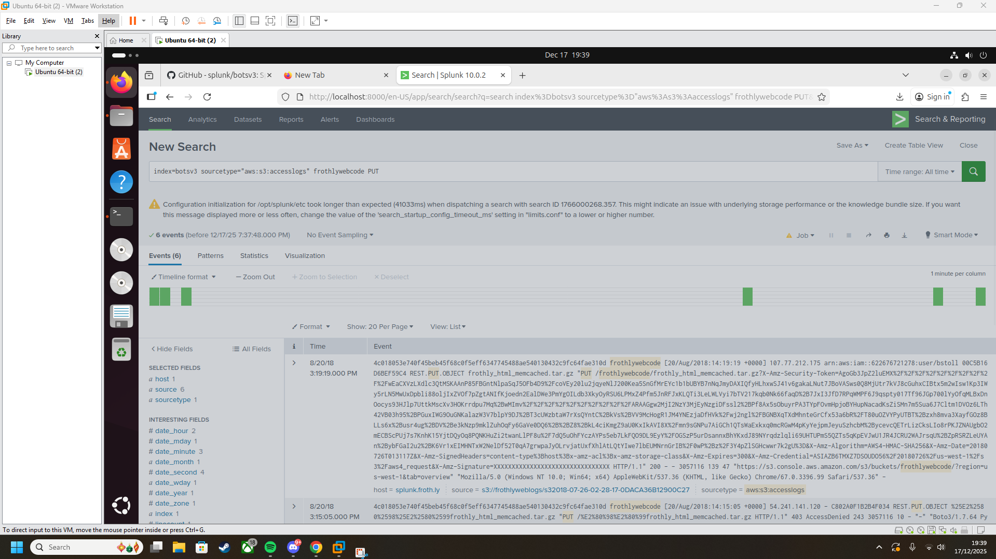

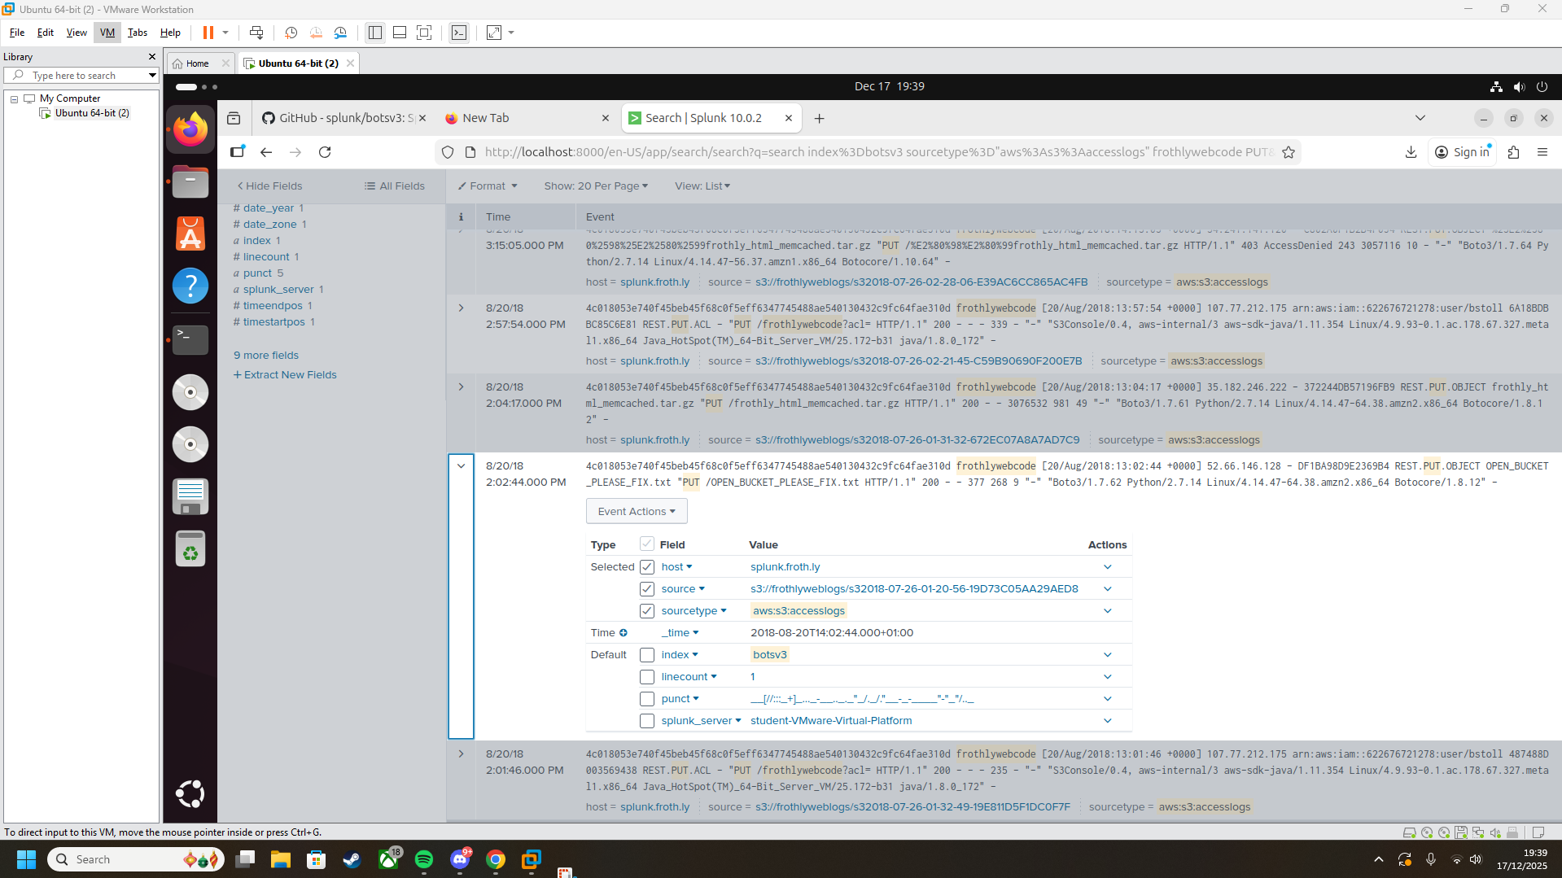Says in the main header

Question 8

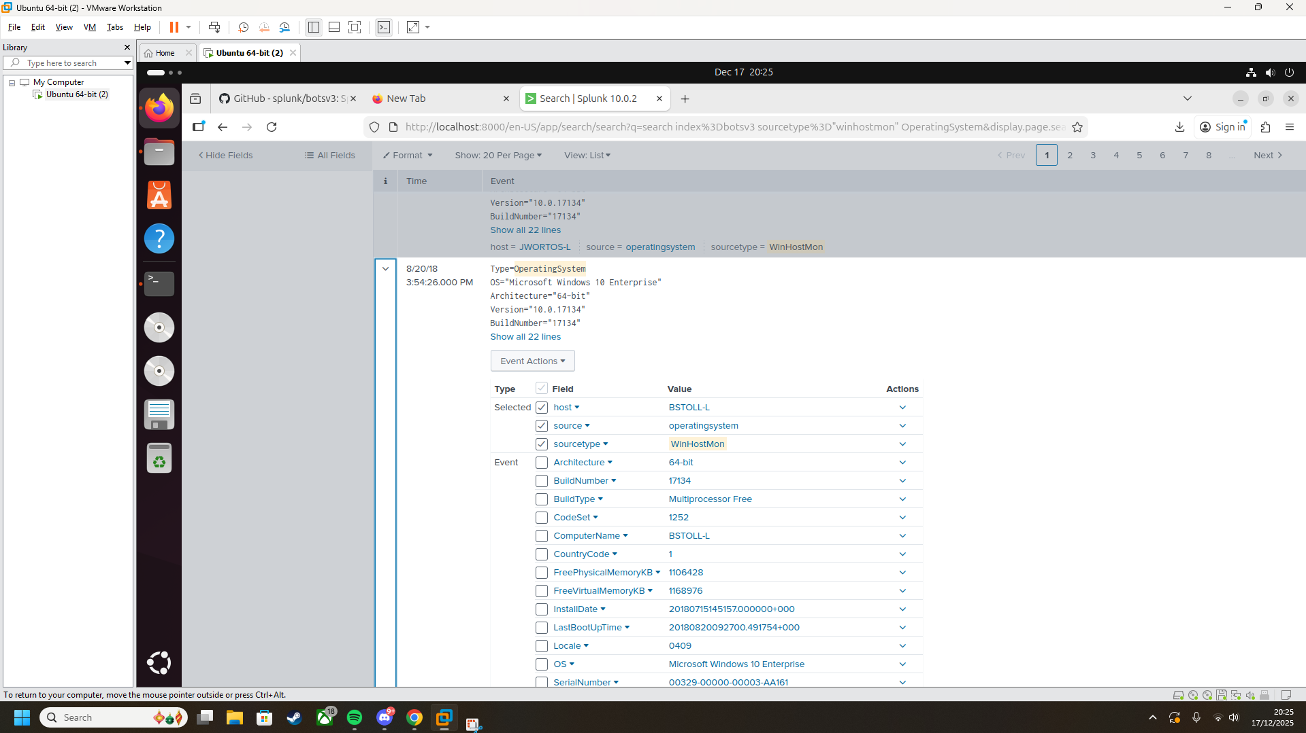

Only one using Windows 10 Enterprise

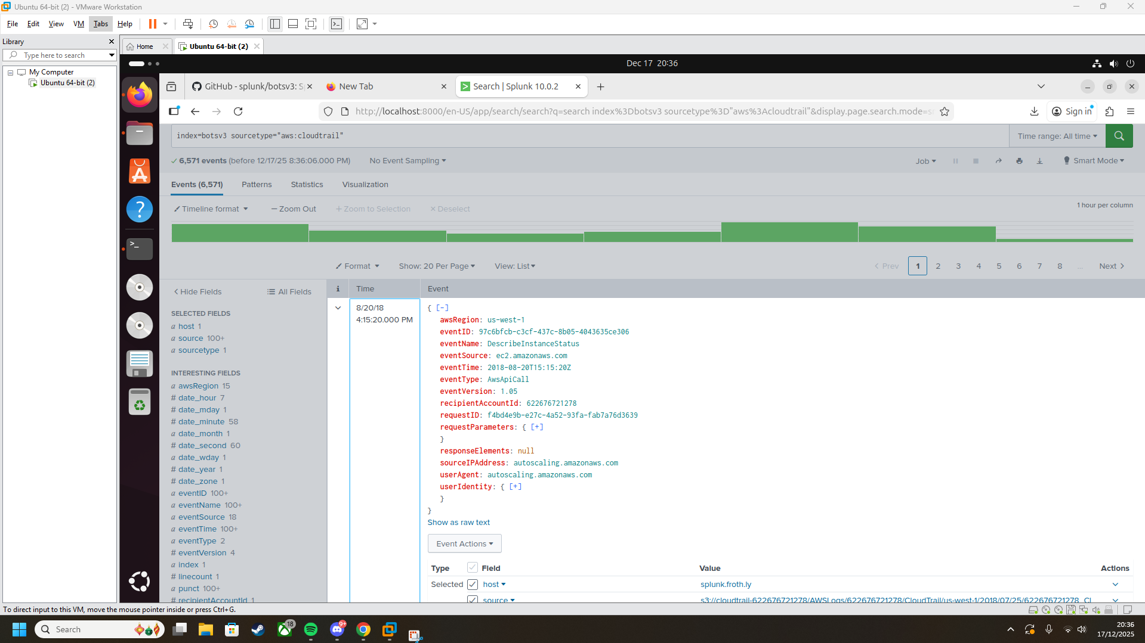Every host is listed under froth.ly

1. bstoll,btun,splunk_access,web_admin

2. userIdentity.sessionContext.attributes.mfaAuthenticated

3. E5-2676

4. ab45689d-69cd-41e7-8705-5350402cf7ac

**5. bstoll**

**6. frothlywebcode**

**7. OPEN_BUCKET_PLEASE_FIX.txt**

**8. BSTOLL-L.froth.ly**

**Other screenshots**

**////////splunk installation///////////**

**I missed some screenshots originally installing Splunk so went back to get them at a later date**

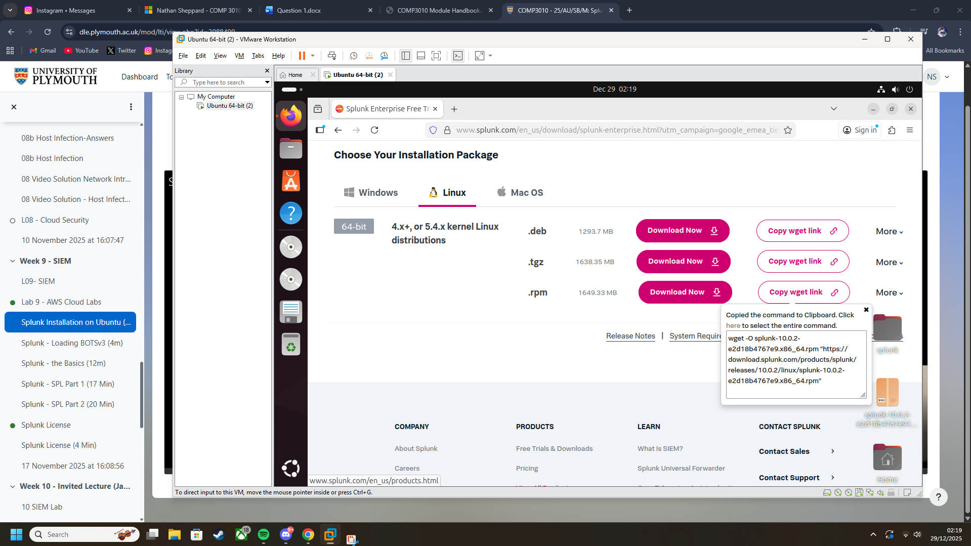

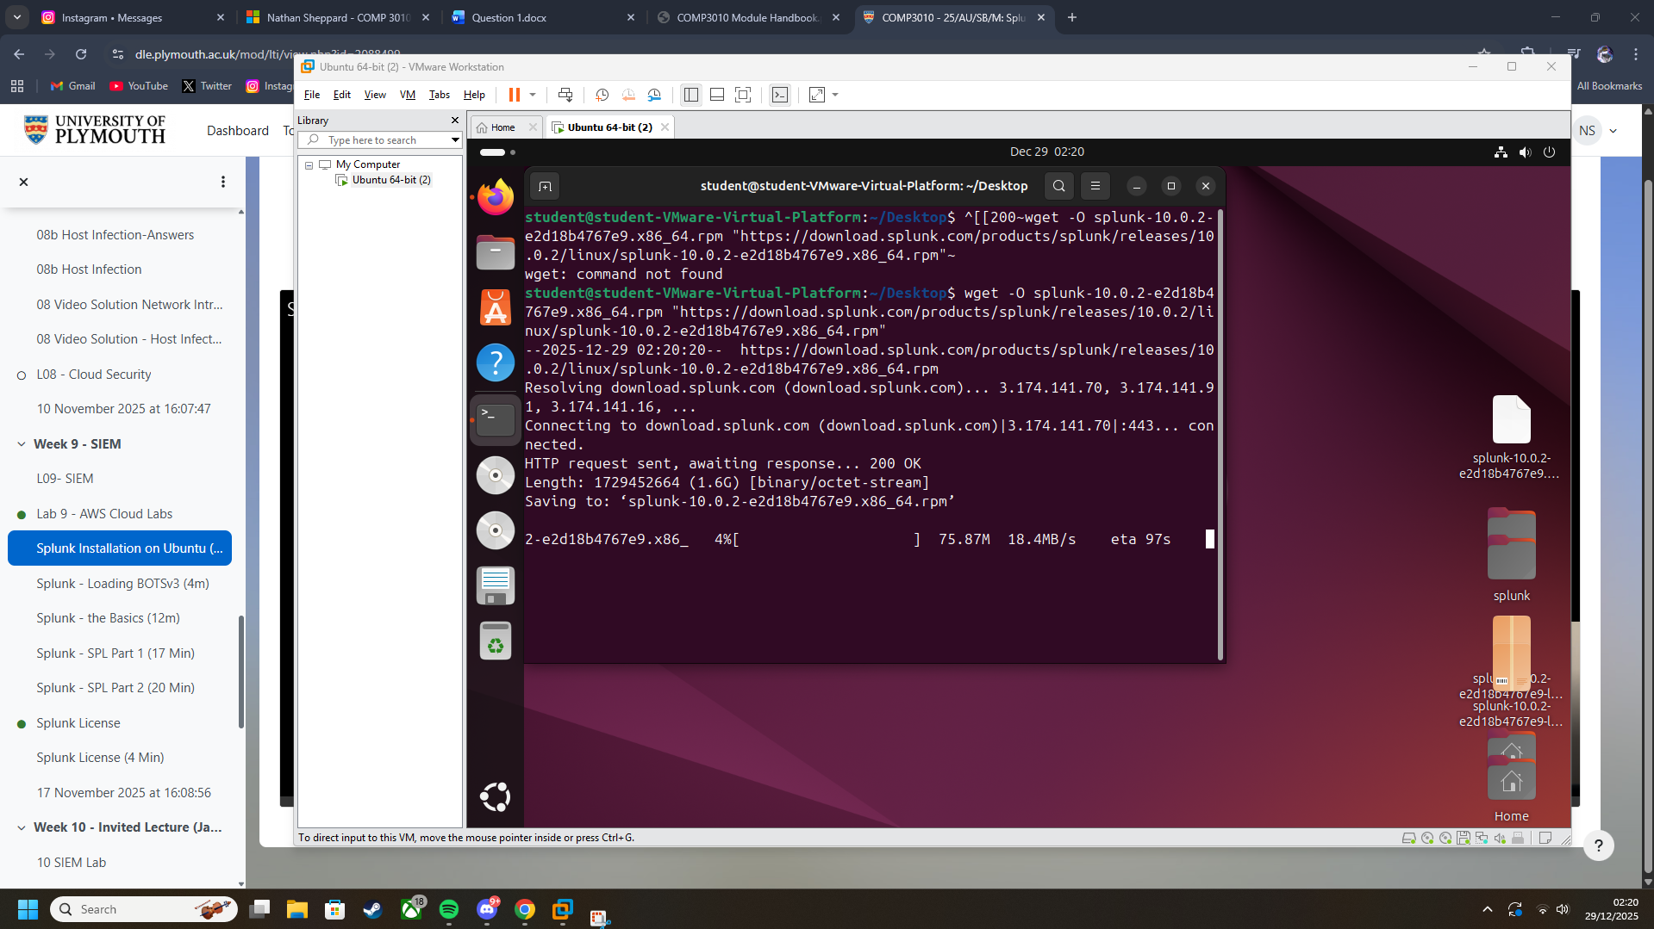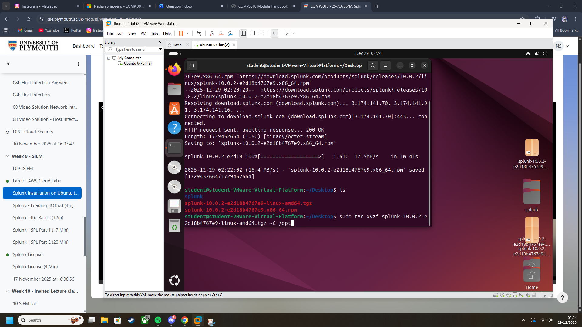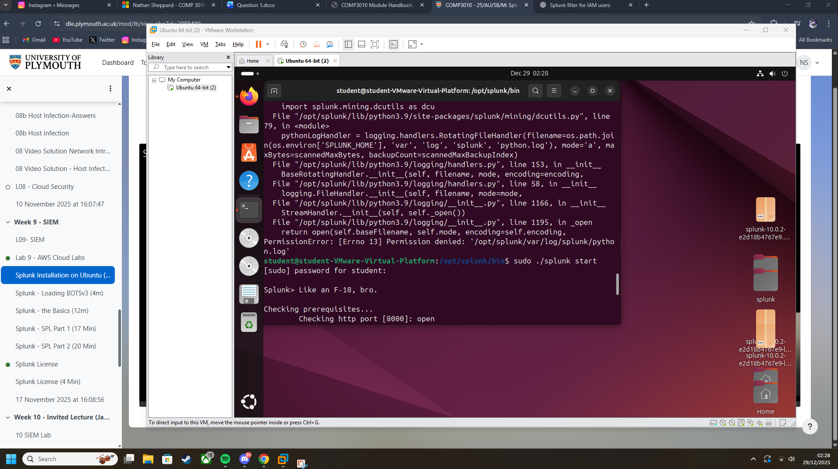

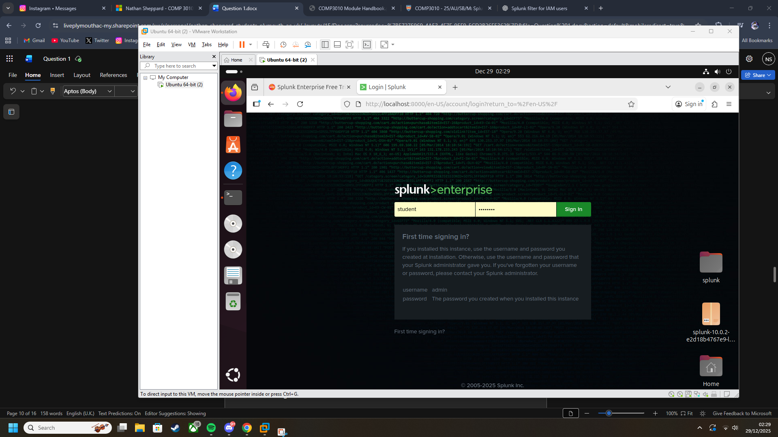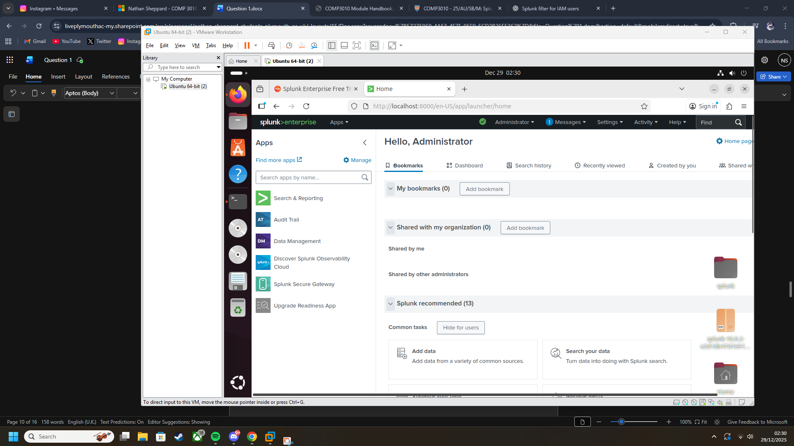

Splunk is now set up and running

**Loading botsv3**

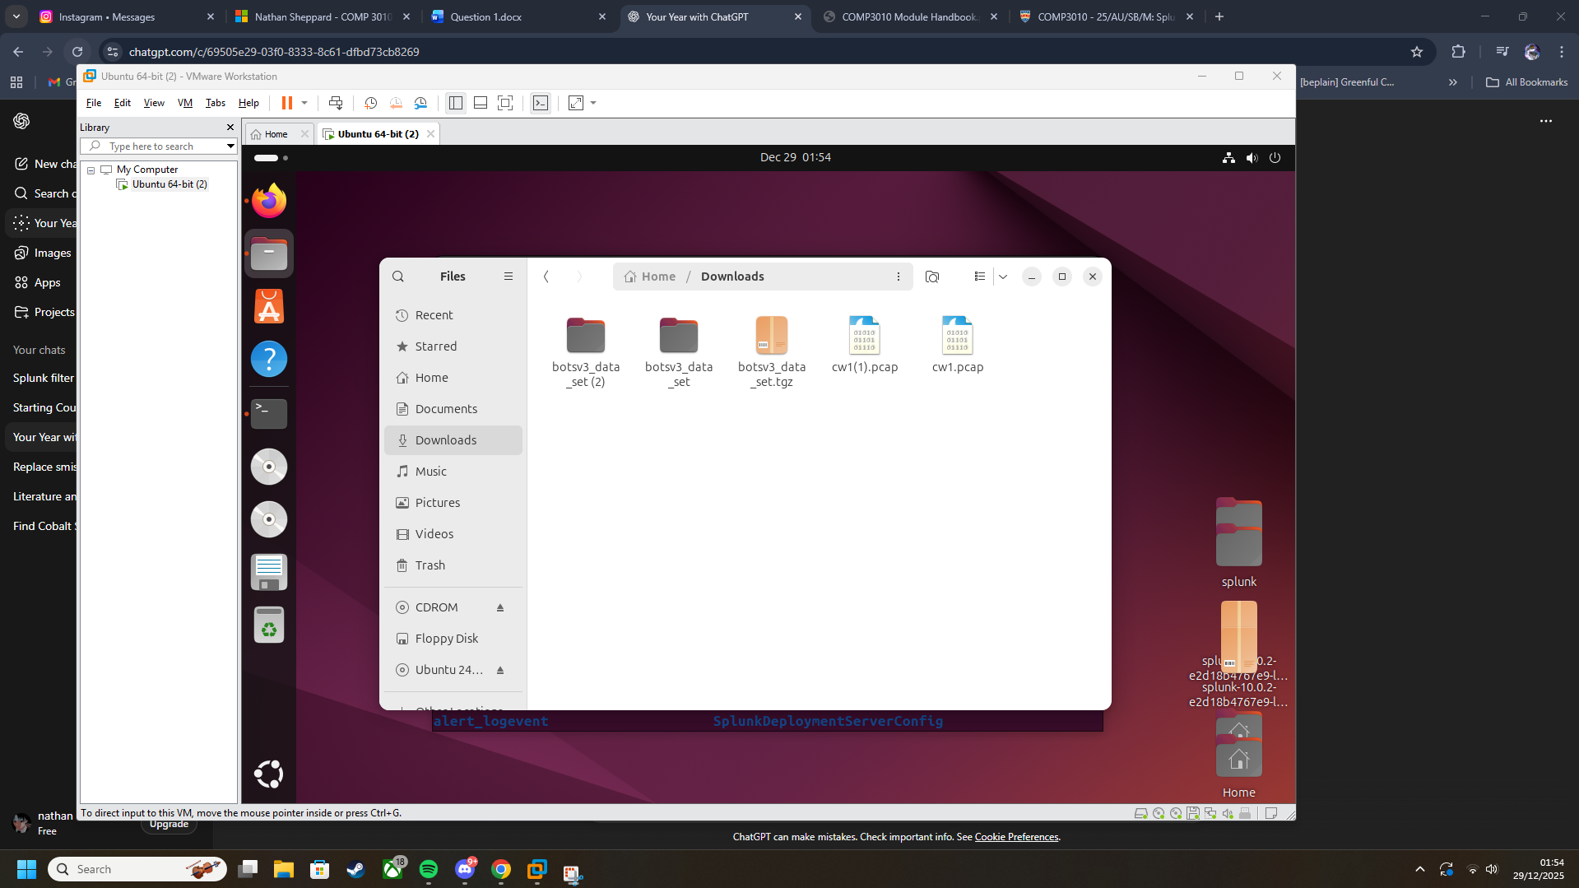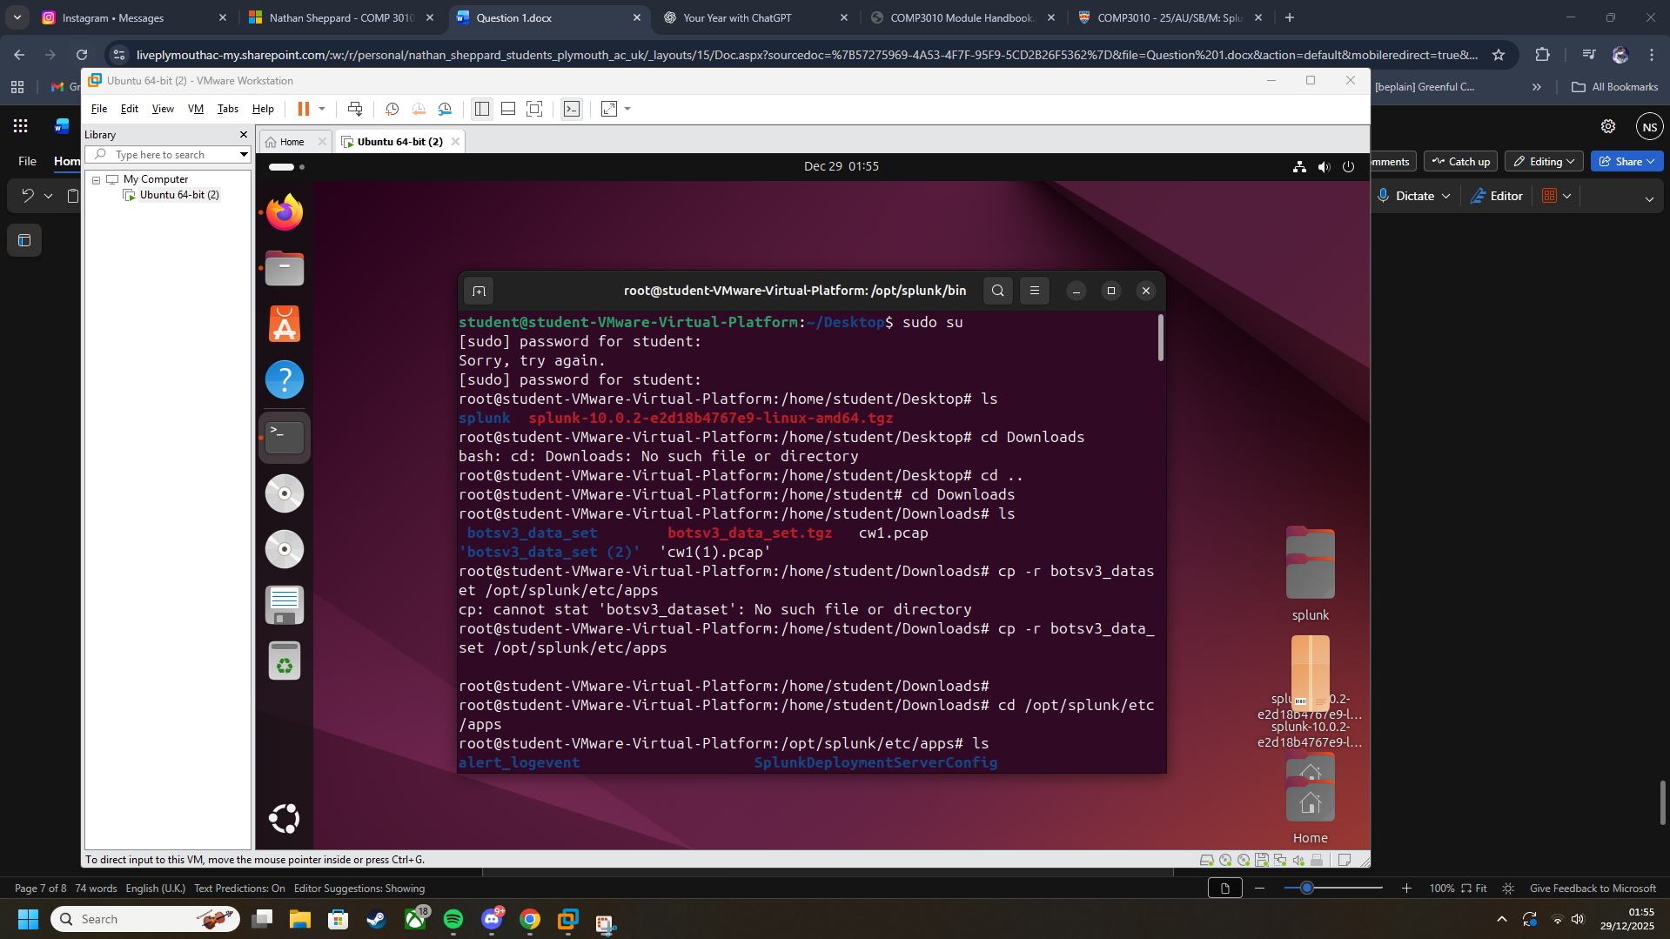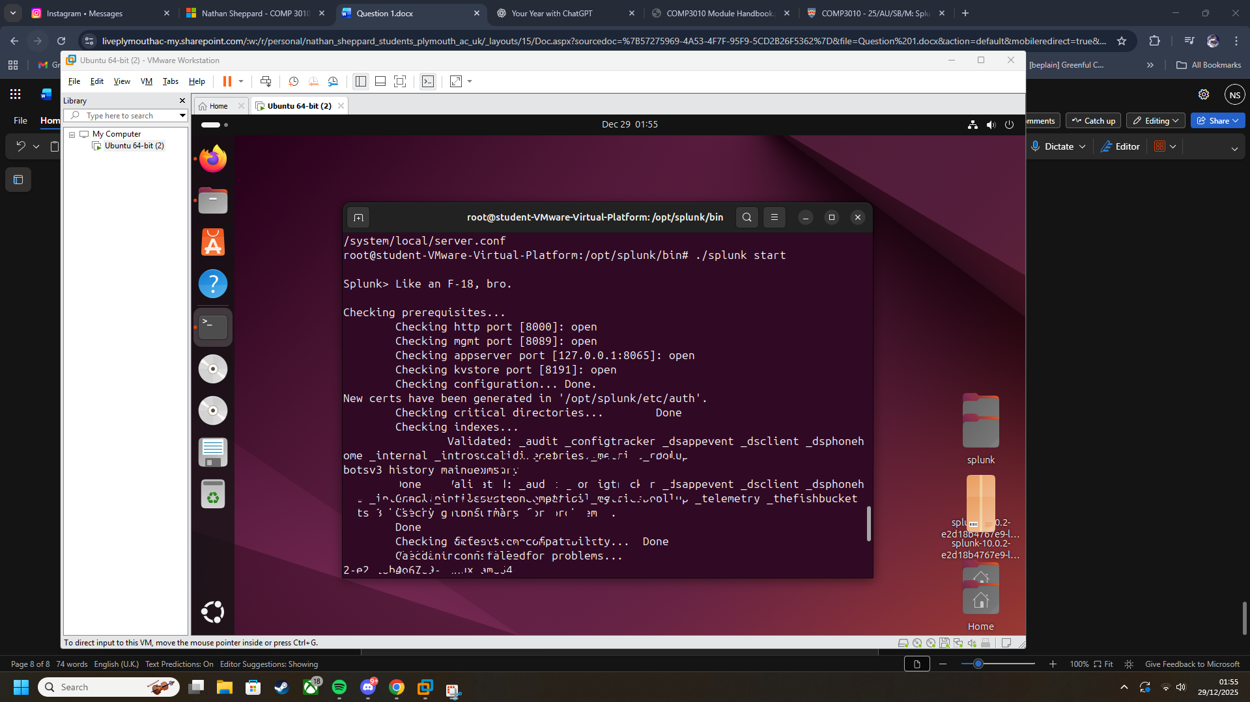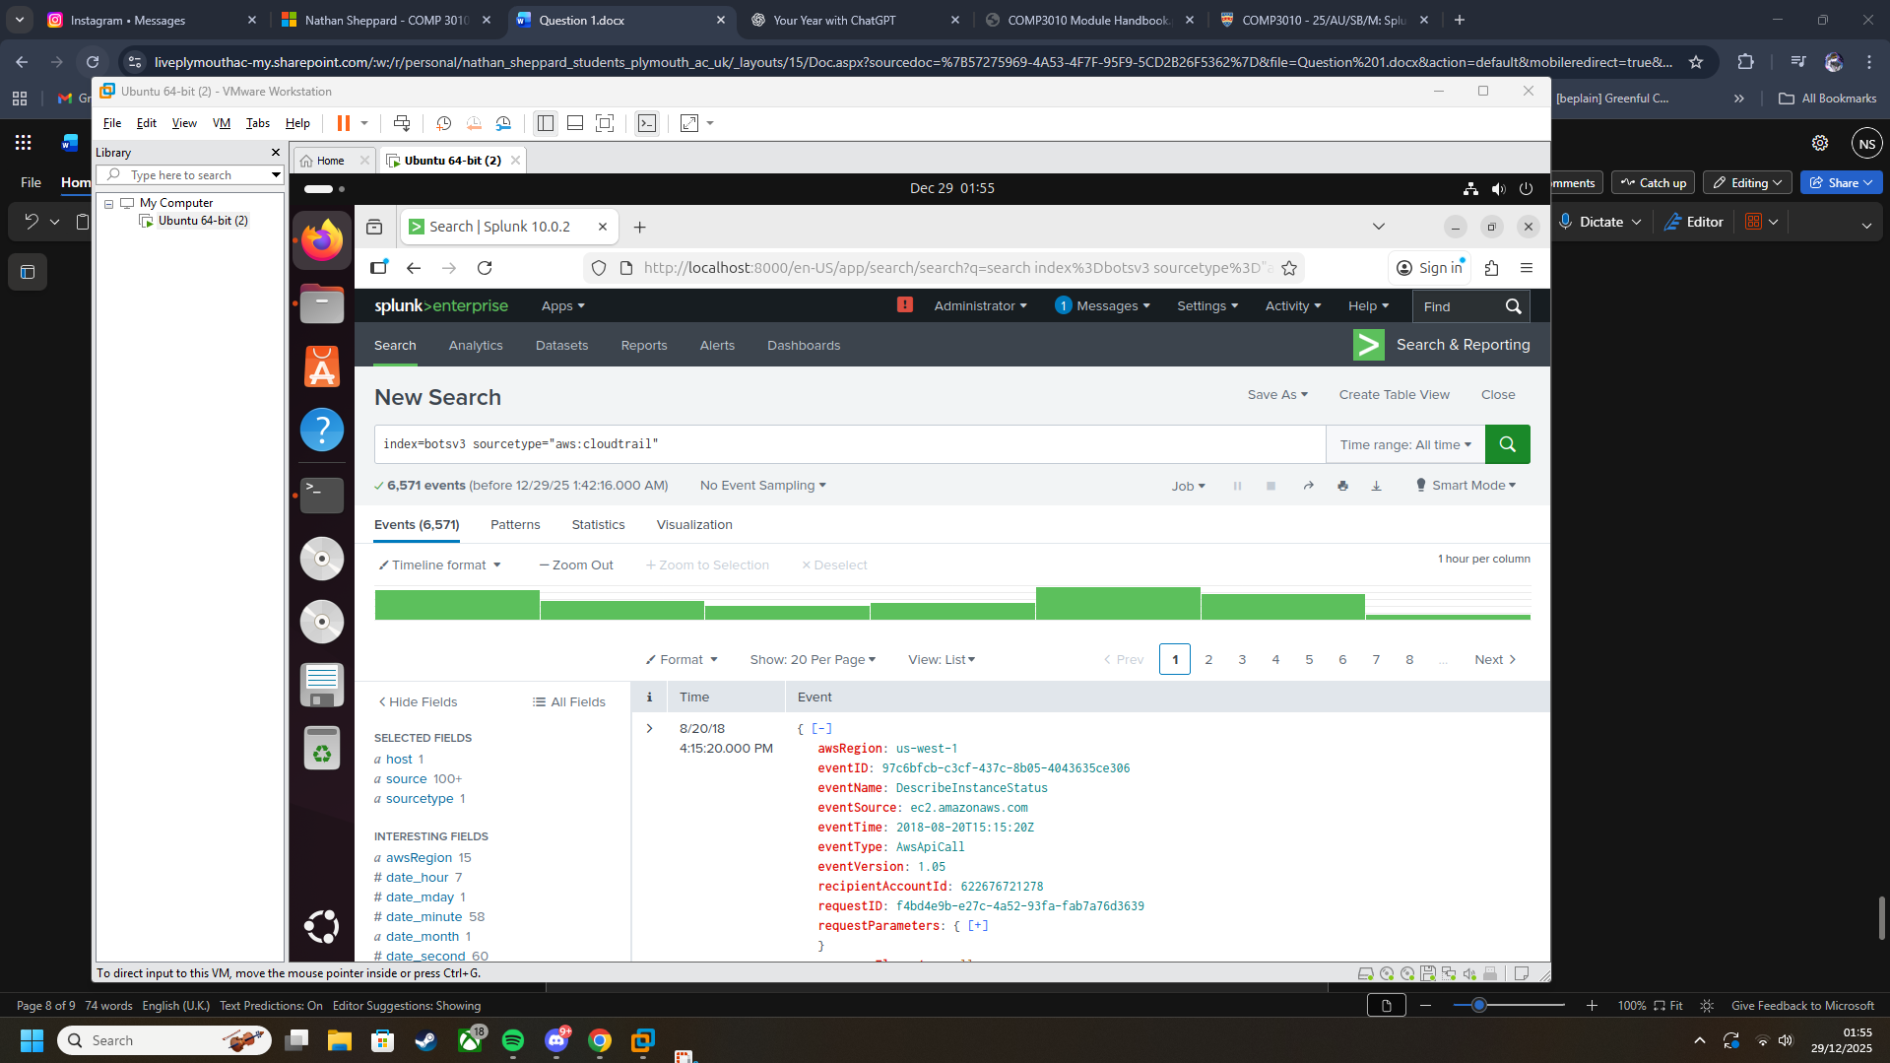

**Other screenshots**

**Using the command below, I found when the bucket was set to all users**

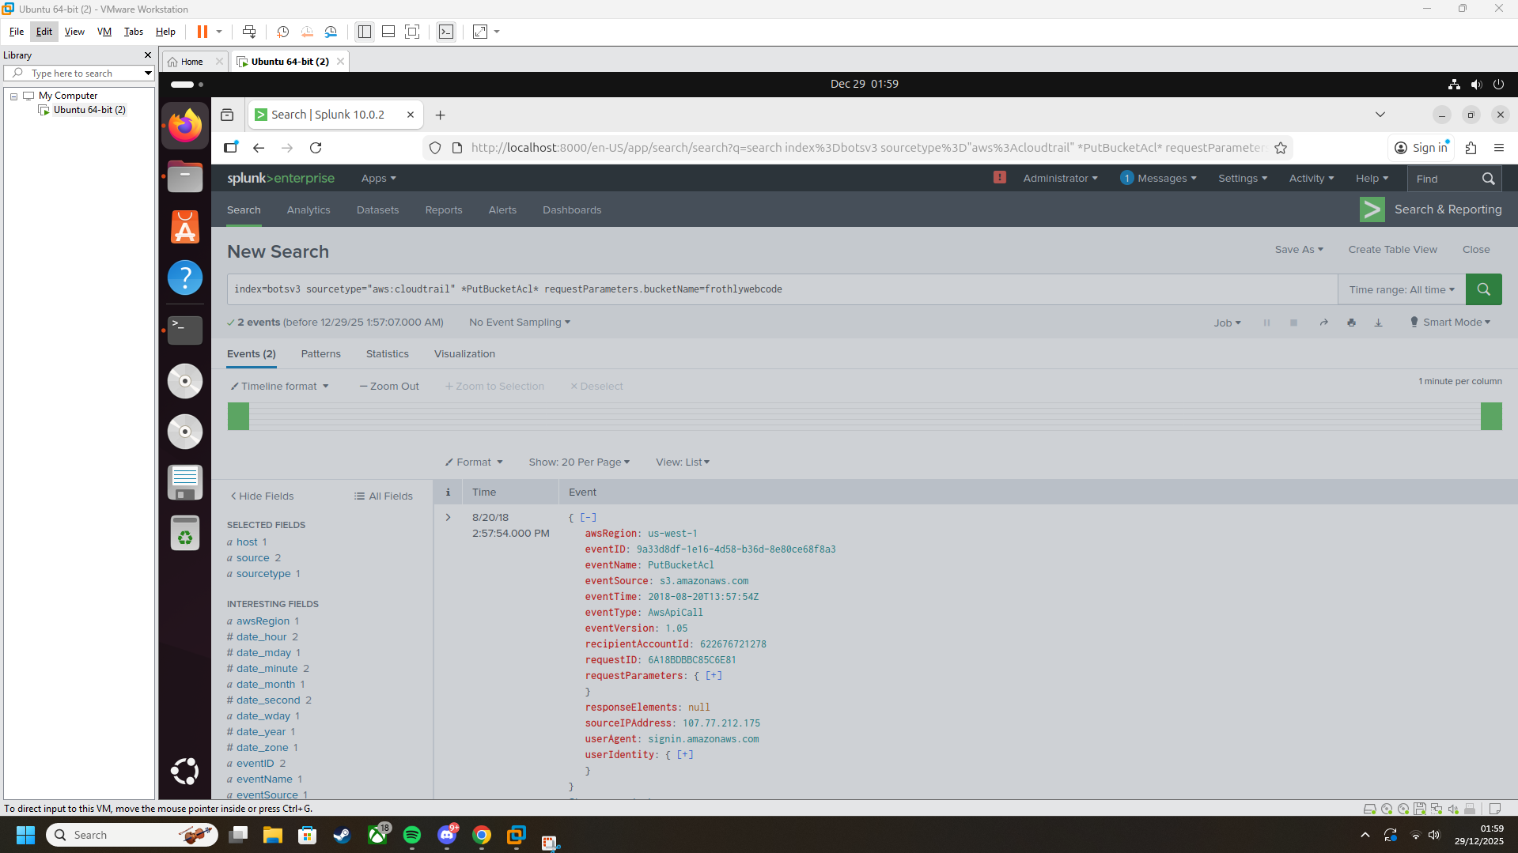

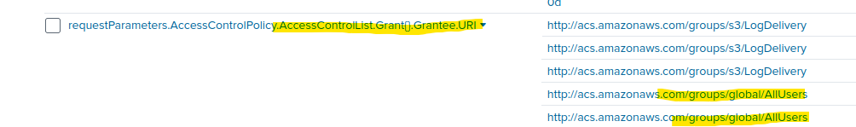

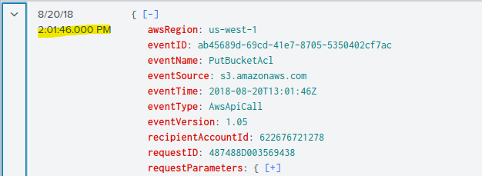

And when it was set back to private after

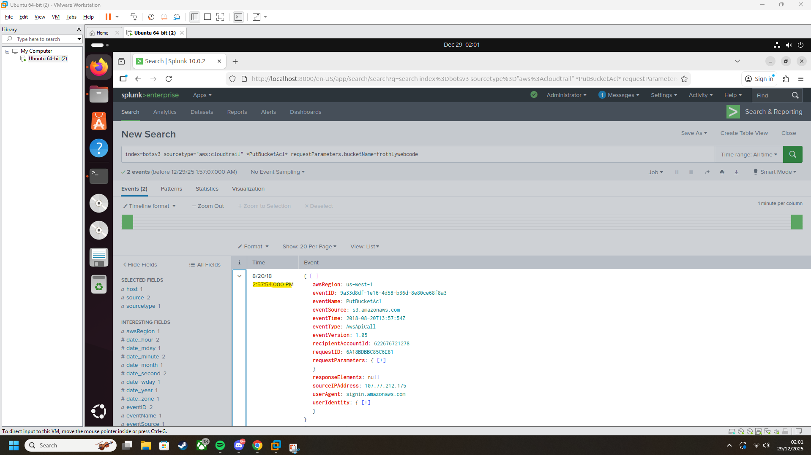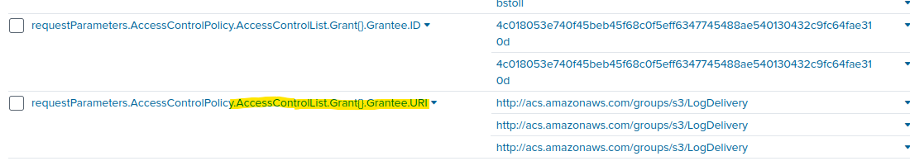

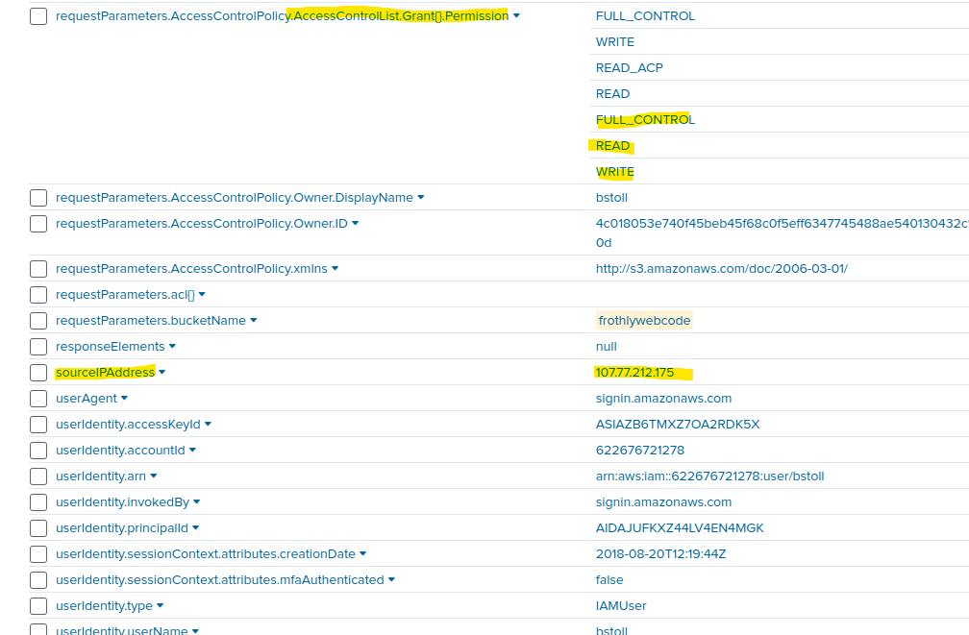This shows the IP address of the account which made the bucket public

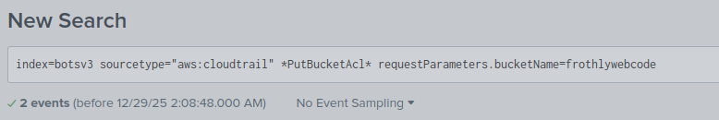

Using this command again we can confirm the responsible user.

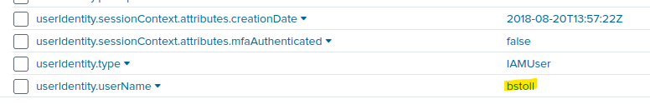

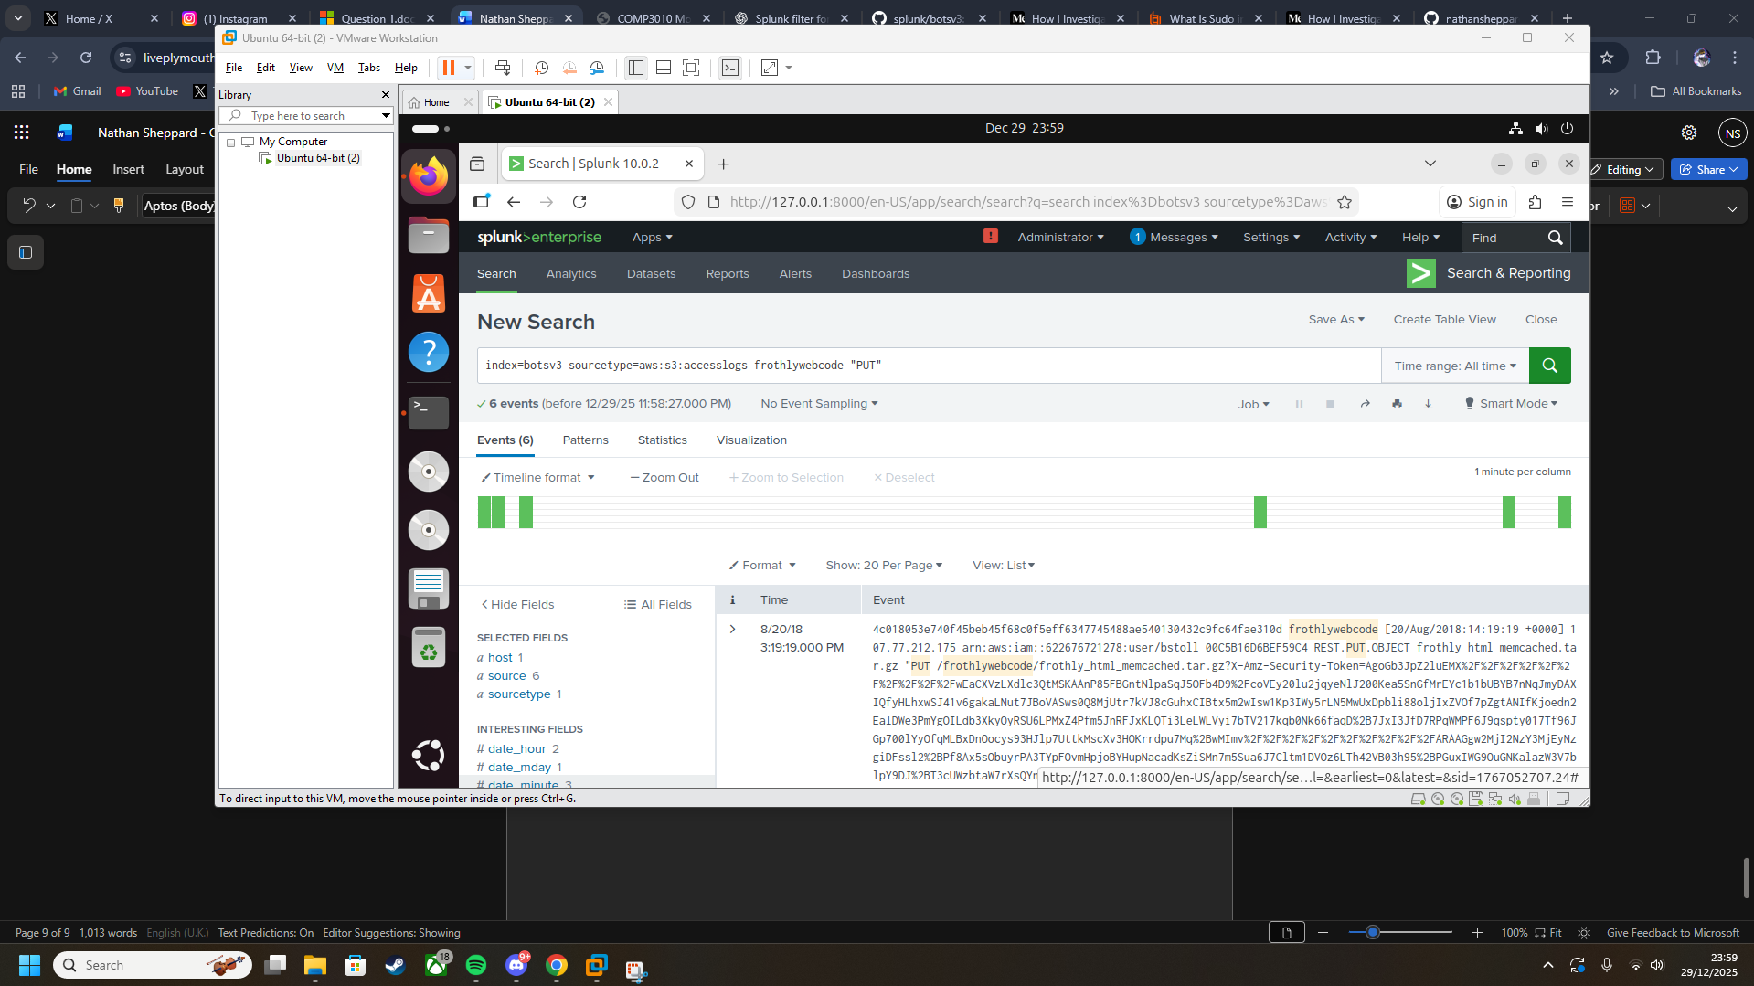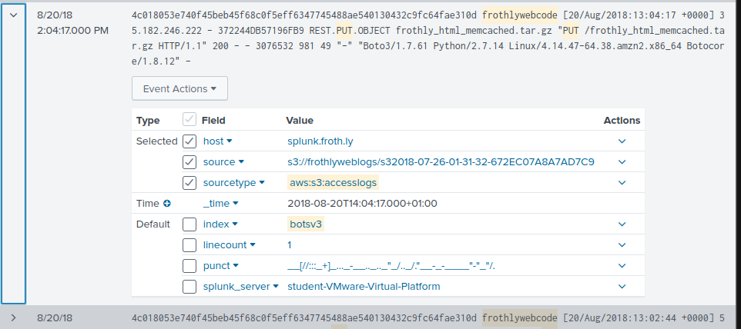

Using this command, the file uploaded while the bucket was public is shown. It is a tar.gz file.